Informe Laboratorio 1 Programación

Nombres y Apellidos del estudiante: **David Nuñez Mejía**

Profesor: Diego Camilo Talero Osorio

1. **Averigua y escribe el código ASCII correspondiente, tanto en decimal como**

**en   binario, a   las   letras   de   sus   nombres   y   apellidos.**

**Distinguir   entre mayúsculas/minúsculas, y sin acentos.**

**Crear una tabla donde las filas sean los caracteres del nombre y las columnas sean (carácter, Decimal ASCII, Binario)**

Decimal

Binario

Carácter

|  |  |  |
| --- | --- | --- |
| David | Nuñez | Mejia |
| 01000100 01100001 01110110 01101001 01100100 | 01001110 01110101 11000011 10110001 01100101 01111010 | 01001101 01100101 01101010 01101001 01100001 |
| 68 97 118 105 100 | 78 117 195 177 101 122 | 77 101 106 105 97 10 |

1. **Realiza la conversión a binario del número decimal 843, mostrar proceso.**

2

843

**1**

2

421

1

2

Numero binario es: 1101001011 se cuenta de abajo para arriba

**1**

**1**

**0**

**0**

**1**

**0**

**1**

**0**

**1**

3

2

2

2

2

2

2

6

13

26

52

105

210

2

1. **Realiza la conversión tanto a decimal como a hexadecimal de los números binarios, mostrar proceso.**
2. 11100101011110.
3. 1111111111111.
4. 100000000001.
5. 10101011110000.
6. **11100101011110.**

|  |  |  |  |  |  |  |  |  |  |  |  |  |  |  |
| --- | --- | --- | --- | --- | --- | --- | --- | --- | --- | --- | --- | --- | --- | --- |
| 214 | 213 | 212 | 211 | 210 | 29 | 28 | 27 | 26 | 25 | 24 | 23 | 22 | 21 | 20 |
| 16384 | 8192 | 4096 | 2048 | 1024 | 512 | 256 | 128 | 64 | 32 | 16 | 8 | 4 | 2 | 1 |
|  | 1 | 1 | 1 | 0 | 0 | 1 | 0 | 1 | 0 | 1 | 1 | 1 | 1 | 0 |

2+4+8+16+64+256+2048+4096+8192= **14686** Numero decimal

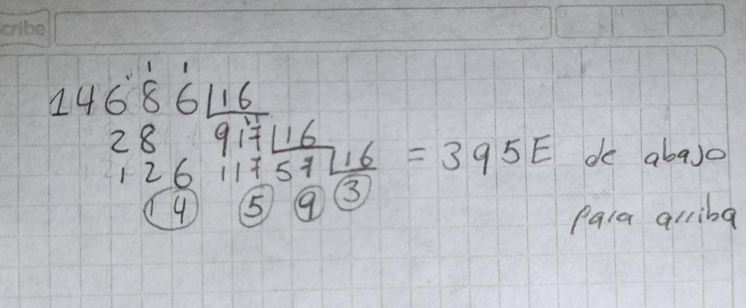

1. **1111111111111**.

|  |  |  |  |  |  |  |  |  |  |  |  |  |  |  |
| --- | --- | --- | --- | --- | --- | --- | --- | --- | --- | --- | --- | --- | --- | --- |
| 214 | 213 | 212 | 211 | 210 | 29 | 28 | 27 | 26 | 25 | 24 | 23 | 22 | 21 | 20 |
| 16384 | 8192 | 4096 | 2048 | 1024 | 512 | 256 | 128 | 64 | 32 | 16 | 8 | 4 | 2 | 1 |
|  |  | 1 | 1 | 1 | 1 | 1 | 1 | 1 | 1 | 1 | 1 | 1 | 1 | 1 |

1+2+4+8+16+32+64+128+256+512+1024+2048+4096= **8191** Numero decimal

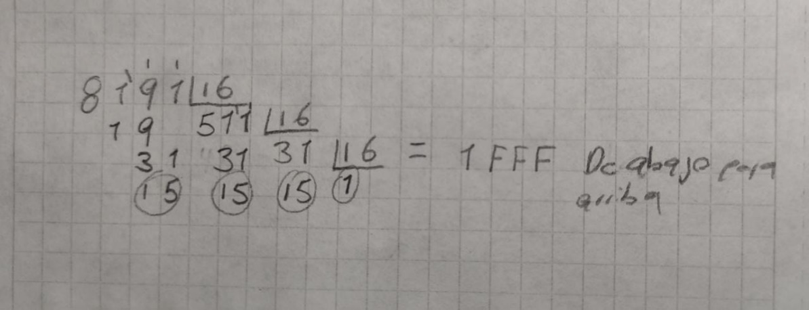

1. **100000000001.**

|  |  |  |  |  |  |  |  |  |  |  |  |  |  |  |
| --- | --- | --- | --- | --- | --- | --- | --- | --- | --- | --- | --- | --- | --- | --- |
| 214 | 213 | 212 | 211 | 210 | 29 | 28 | 27 | 26 | 25 | 24 | 23 | 22 | 21 | 20 |
| 16384 | 8192 | 4096 | 2048 | 1024 | 512 | 256 | 128 | 64 | 32 | 16 | 8 | 4 | 2 | 1 |
|  |  |  | 1 | 0 | 0 | 0 | 0 | 0 | 0 | 0 | 0 | 0 | 0 | 1 |

1+2048 = **2049** Numero decimal

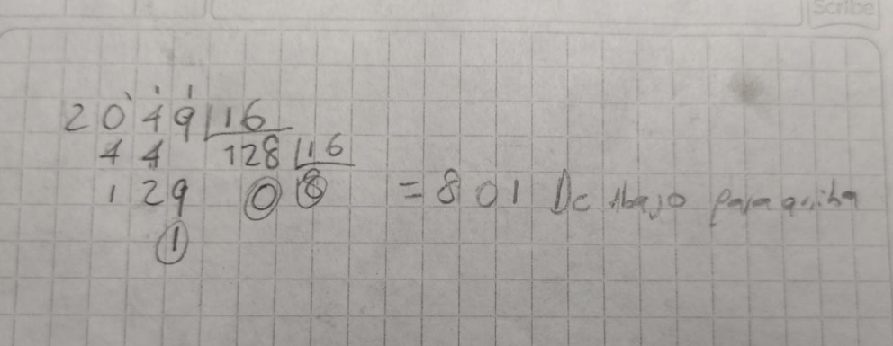

1. **10101011110000.**

|  |  |  |  |  |  |  |  |  |  |  |  |  |  |  |
| --- | --- | --- | --- | --- | --- | --- | --- | --- | --- | --- | --- | --- | --- | --- |
| 214 | 213 | 212 | 211 | 210 | 29 | 28 | 27 | 26 | 25 | 24 | 23 | 22 | 21 | 20 |
| 16384 | 8192 | 4096 | 2048 | 1024 | 512 | 256 | 128 | 64 | 32 | 16 | 8 | 4 | 2 | 1 |
|  | 1 | 0 | 1 | 0 | 1 | 0 | 1 | 1 | 1 | 1 | 0 | 0 | 0 | 0 |

16+32+64+128+512+2048+8192= **10992** Numero Binario

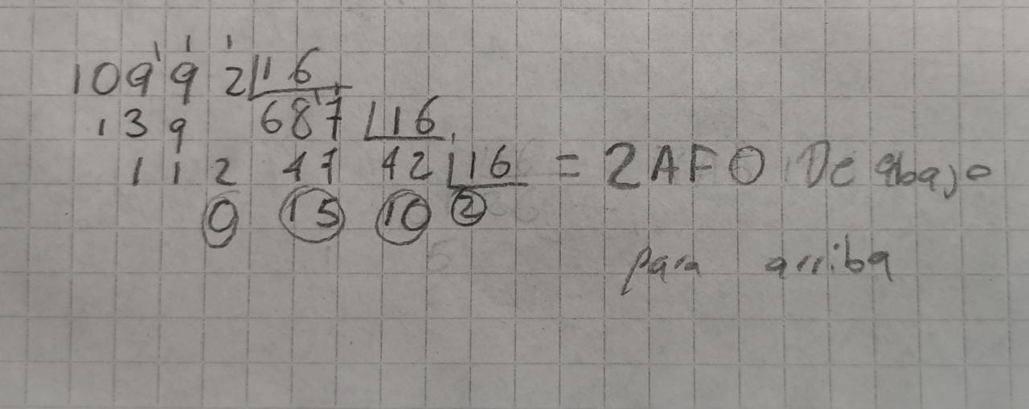

1. **Construir una tabla con la representación de los 32 primeros números en los sistemas de numeración hexadecimal, decimal y binario.**

|  |  |  |
| --- | --- | --- |
| Decimal | Hexadecimal | Binario |
| 1 | 1 | 0001 |
| 2 | 2 | 0010 |
| 3 | 3 | 0011 |
| 4 | 4 | 0100 |
| 5 | 5 | 0101 |
| 6 | 6 | 0110 |
| 7 | 7 | 0111 |
| 8 | 8 | 1000 |
| 9 | 9 | 1001 |
| 10 | A | 1010 |
| 11 | B | 1011 |
| 12 | C | 1100 |
| 13 | D | 1101 |
| 14 | E | 1110 |
| 15 | F | 1111 |
| 16 | 10 | 10000 |
| 17 | 11 | 10001 |
| 18 | 12 | 10010 |
| 19 | 13 | 10011 |
| 20 | 14 | 10100 |
| 21 | 15 | 10101 |
| 22 | 16 | 10110 |
| 23 | 17 | 10111 |
| 24 | 18 | 11000 |
| 25 | 19 | 11001 |
| 26 | 1A | 11010 |
| 27 | 1B | 11011 |
| 28 | 1C | 11100 |
| 29 | 1D | 11101 |
| 30 | 1E | 11110 |
| 31 | 1F | 11111 |
| 32 | 20 | 100000 |

1. **¿Cuál es el siguiente número hexadecimal al 19F**

**1A0**